# SSIS – Adventure Works and Wide World Importers Merge

## Admin Tasks: To check database integrity and backup databases.

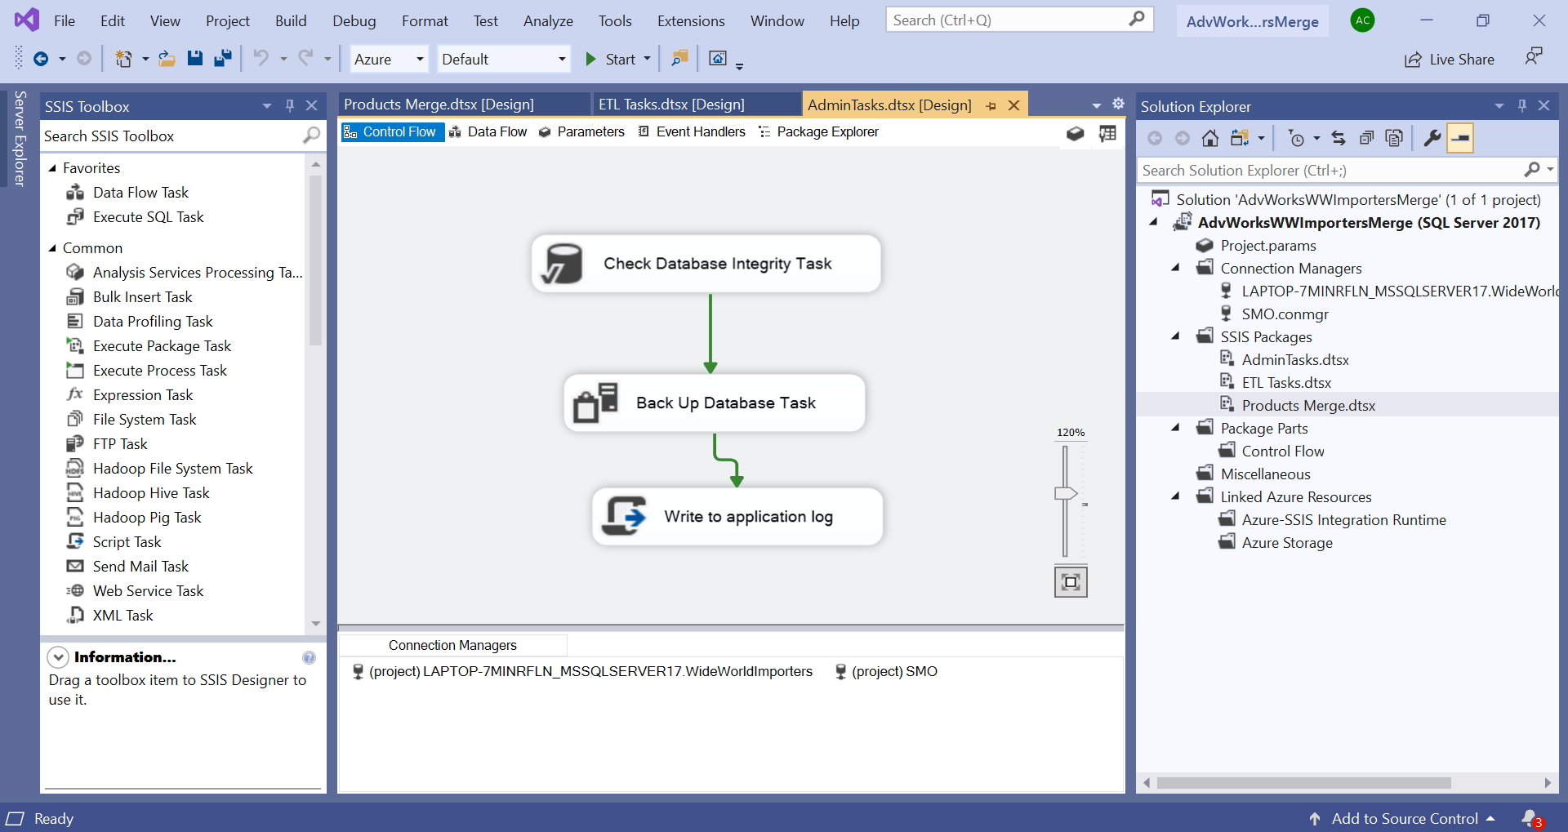

## ETL Tasks:

* Create space utilization report for Adventure Works Database
* Load the CSV files contain space utilization data for Wide World Import Database.
* This report will help us determine approx. time required to load and merge these 2 databases.

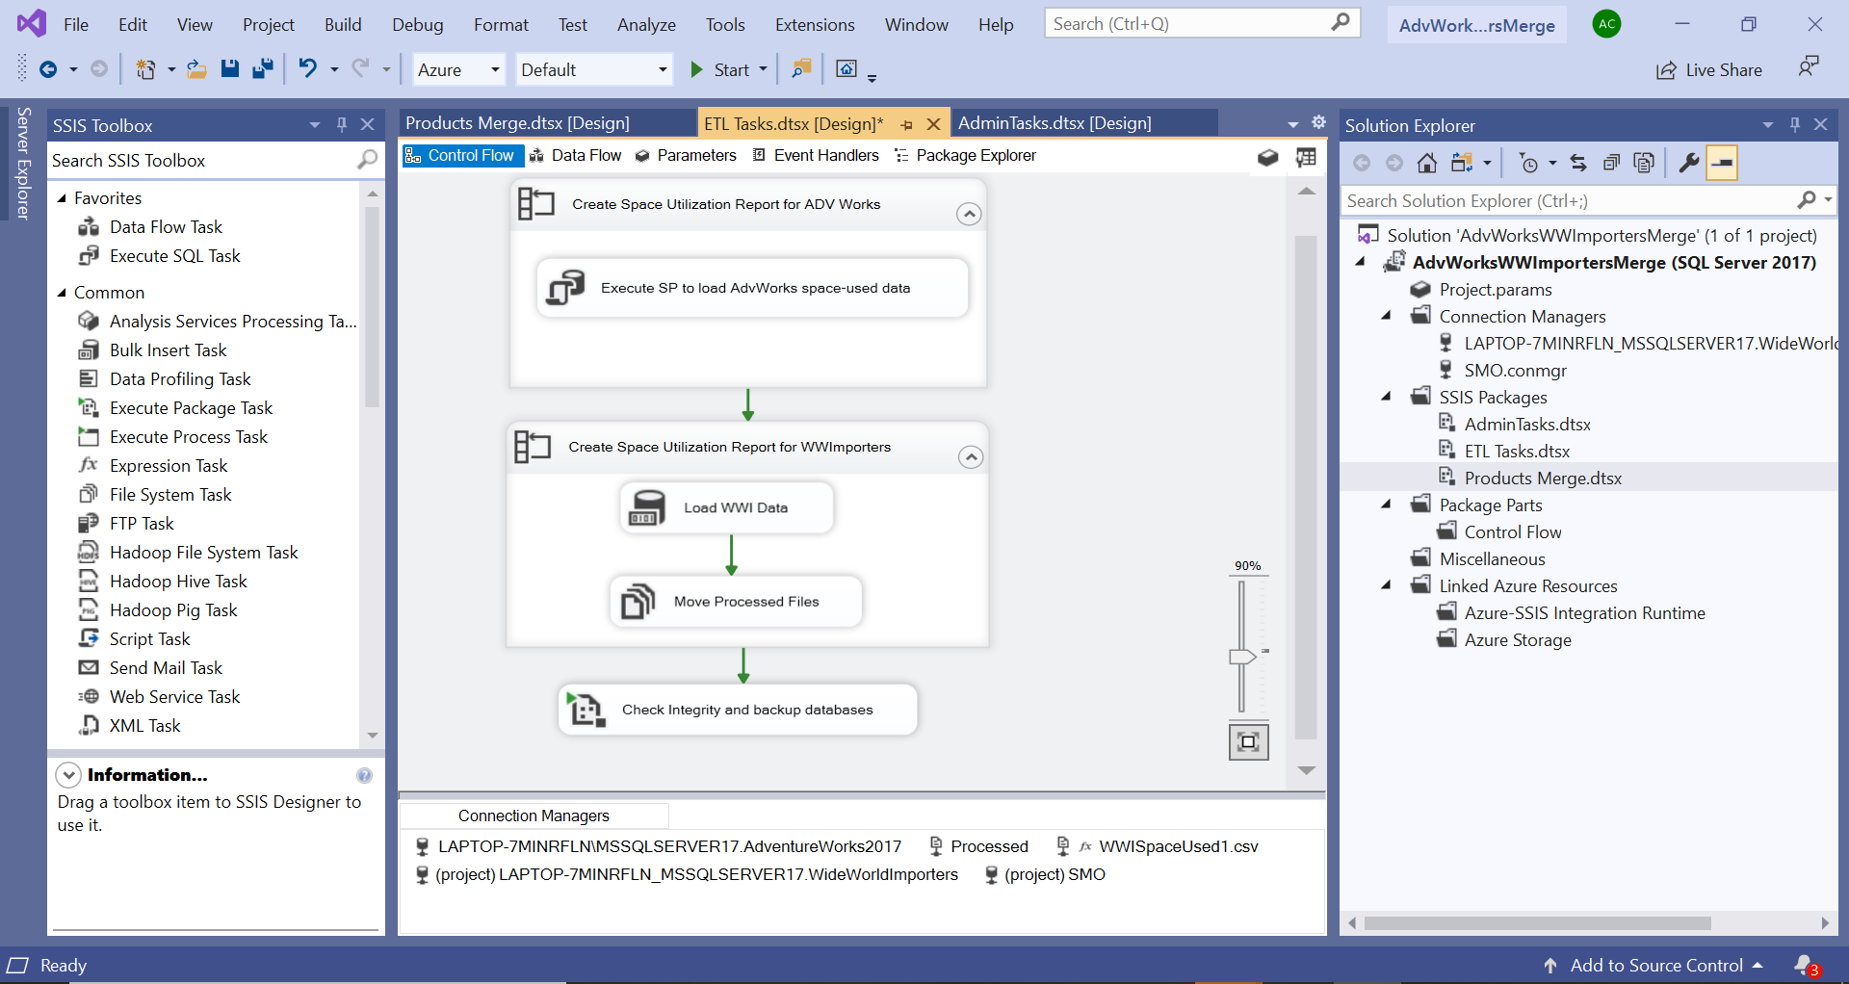

## Products Merge:

* OLE DB Source: Import products data from Adventure Works and Wide World Importers Database.
* Adventure Works (AW) Transformations:

1. Conditional Split: Conditional Split on column itemtype to segregate Clothing and Products data.

* Wide World Importers (WWI) Transformations:

1. Derived Column: Calculate Final Cost as UnitPrice * (1 + TaxRate / 100)
2. Data Conversion: Change data type of Final Cost and Retail Price to Currency
3. Sort: Sort by Product Name as we are going to merge which requires data to be in sorted format.
4. Lookup: Look up color values based on Color ID and redirect rows with no matches to “No Match” output.
5. Merge: Merge match and no-match outputs from lookup task.
6. Conditional Split: Conditional Split on column itemtype to segregate Clothing and Products data.
7. Union of Clothing Data from AW and WWI DBs and Union of Products Clothing
8. Multicast: Create an additional csv for vendors containing just Merged products data without price information.

* OLE DB Destination: Merged Clothing output is loaded to Clothes DB and Merged Products output to Products DB

